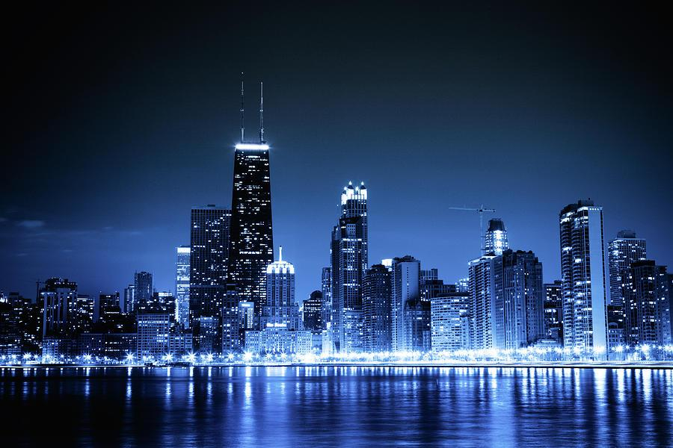

Delta Phi Delta National Conference 2025
“A WICKED 25 Years 🫧🧹”
🗓️ Conference Itinerary: June 26–30th, 2025
📍 Location: Chicago, IL
**Denotes Spaces that HEART Auxiliary members may attend

Thursday
June 26, 2025
Current National & Regional Board Members and Chapter Delegates Only

Arrival & Check-in After 3:00 pm
Holiday Inn Chicago SW Countryside Banquets & Conference Center
6201 Joliet Rd, Countryside, IL 60525
For National, Regional Board Members & Delegates
• 5:00 PM – 7:00 PM – Board Members’ Briefing Meeting - Cornell Room
• 7:00 PM –8:30 PM Delegates’ Briefing Meeting - Cornell Room
Led by Brother Sergio Green and Soror Dr. Apryl Riley
• 9:00PM Evening – Group Dinner/ Karaoke
Tavern on Lagrange-14000 Croissant Drive Burnham,IL 14000 Croissant Drive Burnham, IL 60633

Friday
June 27, 2025
Registration & Delegate Voting
Holiday Inn Chicago SW Countryside Banquets & Conference Center
6201 Joliet Rd, Countryside, IL 60525
• Morning – Breakfast provided by the hotel for members staying at the hotel.
Provided by hotel; Time 7:00am-10:00am
• 10:00 AM – 12:00 PM – Delegates’ Voting Session
Led by Brother Sergio Green and Soror Dr. Apryl Riley
Cornell Room
• After 3:00 PM – Arrival & Check-in for General Members & Guests **
Holiday Inn Chicago SW Countryside Banquets & Conference Center
6201 Joliet Rd, Countryside, IL 60525
• 5:00 PM – 7:00 PM – Vendor Hall & Meet-and-Greet **
Cornell Room
Light refreshments served
• 5:00 PM – 7:00 PM – Registration
Cornell Room

• 8:00 PM – 12:00AM – Pajama Party
**Cornell Room
6201 Joliet Rd, Countryside, IL 60525

Saturday
June 28, 2025
Business Meetings & Chapter Warz

Holiday Inn Chicago SW Countryside Banquets & Conference Center
6201 Joliet Rd, Countryside, IL 60525
• Morning – Breakfast provided by the hotel for members staying at the hotel.
Provided by hotel; Time 7:00am-10:00am

• 8:30 AM – 10:50 AM – General Body Meeting
BUSINESS CAUSAL ATTIRE REQUIRED
Moraine Valley Community College
9000 W College Pkwy, Palos Hills, IL 60465
• 11:00 AM – 12:00 PM – Meetings 1, 2 &3 (Concurrent)
Learn more about your Facilitators Here
Mental Health 101:Jasmine Young and Danielle Owens **
- Auditorium 1
JEDI 201: JEDI Committee
- Auditorium 2
NEO 101: Ashley Walker ,Rashad Jackson ,Chanceton Scott-Bennett
- Auditorium 3
• 12:00 PM – 1:00 PM – Lunch **
- Auditorium 1
• 1:10 PM – 2:10 PM – Meetings 4, 5 , 6 (Concurrent)
Prophytes 201 (Panel) :Soror Brionna Windom Soror Candyce Evans Brother Josh McGrier, Brother Nasir Baker and Brother Kyle Davis
- Auditorium 1
Communication 101 Soror Demetria Dodson and Soror Rakiya Johnson
- Auditorium 2
Dance Industry 201 Brother Braven Sloan III **
- Auditorium 3
• 3:00 PM – Stage Time (Host Hotel)
Holiday Inn Chicago SW Countryside Banquets & Conference Center
6201 Joliet Rd, Countryside, IL 60525
Grand Ballroom
- Zeta (3:00-3:20)
- Phi (3:25- 3:45)
- Xi (3:50- 4:10)
- Alpha Theta (4:15- 4:35)
- Alpha Epsilon (4:40- 5:00)
- Pi (5:10- 5:30)
- AK (5:35-5:55)
• 6:00 PM – Doors Open for Chapter Warz (Grand Ballroom)
• Evening – Explore Chicago

Sunday
June 29, 2025
Community service & Celebration

Holiday Inn Chicago SW Countryside Banquets & Conference Center
6201 Joliet Rd, Countryside, IL 60525
• Morning – Breakfast provided by the hotel for members staying at the hotel.
Provided by hotel; Time 7:00am-10:00am

• 8:00 AM – 10:00 AM – MIC/AMIC Session (Hotel Grand Ballroom)
• 10:15 AM – 11:15 PM – Community Service Activity ** (Grand Ballroom)
• 11:30 PM – 12:30 PM – Lunch (On your own) **
• 12:45 PM – 5:45 PM – Dance Workshops **
• 12:45- 1:30 PM – Stretch Session with Soror Karen Boggs
Location: Countryside Room
• 1:40 PM – 2:55 PM – Pro Cheer With Brianna Blount
Location: Countryside Room
• 3:05 PM – 4:20 PM – Hip-Hop With Marcus Motley
Location: Countryside Room
• 4:30 PM – 5:45 PM – Footwork with Pause Eddie
Location: Countryside Room
• 5:45 PM – 8:00 PM – Banquet Preparation **
• 8:00 PM – 12:00 AM – Banquet Celebration **
Theme: A Night In the Enchanted Forest
Location: Grand Ballroom
Attire: Choose a character from Wicked or Wizard of Oz to Inspire your formal look.

Monday
June 30, 2025
Breakfast (Your Choice)
Holiday Inn Chicago SW Countryside Banquets & Conference Center
6201 Joliet Rd, Countryside, IL 60525
• Morning – Breakfast provided by the hotel for members staying at the hotel.
Provided by hotel; Time 7:00am-10:00am

Farewell
Phamily Photos*​​​​​​ 10:00AM
Checkout by 12:00PM

